Crypto Price Alert Script Guide.

# INTRODUCTION

*As a crypto enthusiast and investor, we always want to keep ourselves updated with the current price of our holdings. And we end up keep on refreshing the browser after every 10-15 mins.*

*So, to avoid this, I have written this python script, which will fetch the current price from various exchanges (Koinex, Bittrex, Ethexindia, Bitfinex, CMC) and will display a price alert notification after every 10-15 mins.*

***Below are some notification pics:***

***Koinex Price Alert:* *EthexIndia Price Alert:***

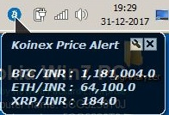 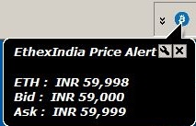

***BitFinex Price Alert***: ***CoinMarketCap (CMC) Price Alert:***

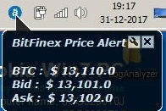 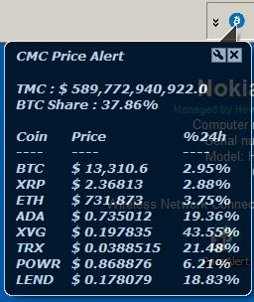

***Biggest Gainers in 24h*:**  ***Biggest Losers in 24h:***

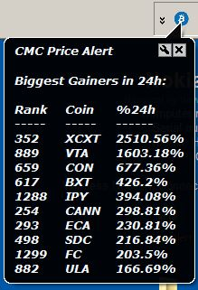 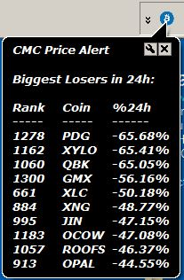

***Biggest Gainers in 1h:*** ***Biggest Losers in 1h:***

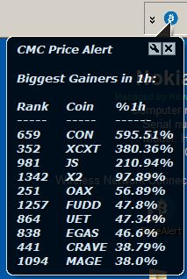 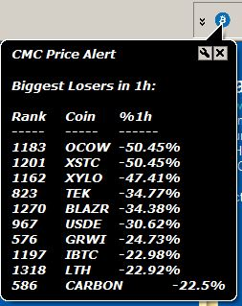

***Bittrex Price Alert***:

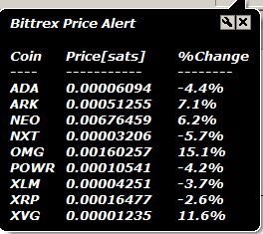

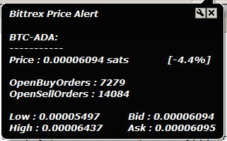

# PREREQUISITES

1. Python 2.7
2. Apart from built-in module of python below packages are needs to be installed.
   * requests
   * pywin32

**Installation Steps:**

1. Unzip the ***PriceAlert-master.zip*** file.

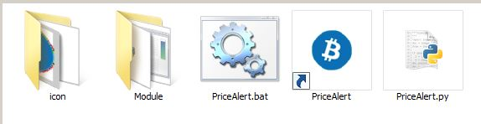

1. Go to ***Module*** directory and install ***python*** and ***pywin32*** packages by just doing the double click on executable file.

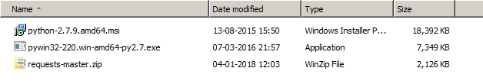

1. Add following locations in environment variables of your system.***C:\Python27;C:\Python27\Scripts;C:\Python27\Lib\site-packages;C:\Python27\Lib;***

* *Right click on* ***Computer*** *icon, select* ***properties*** *and click on tabs shown in below pic.*

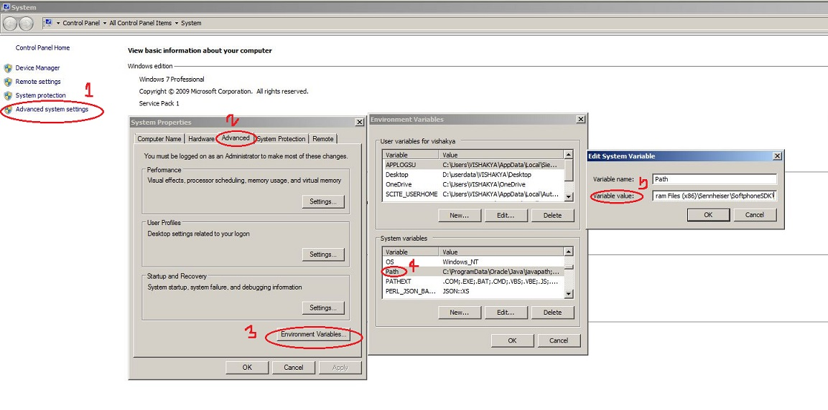

* *Go to* ***variable value*** *field, paste above path at the beginning of the variable field and click on* ***OK*** *button.*

1. Unzip ***requests-master.zip*** file***,*** Go to ***requests-master*** directory, open command prompt (click in address bar, type ***cmd*** and press enter) and run the below command to install the package.

***python setup.py install***

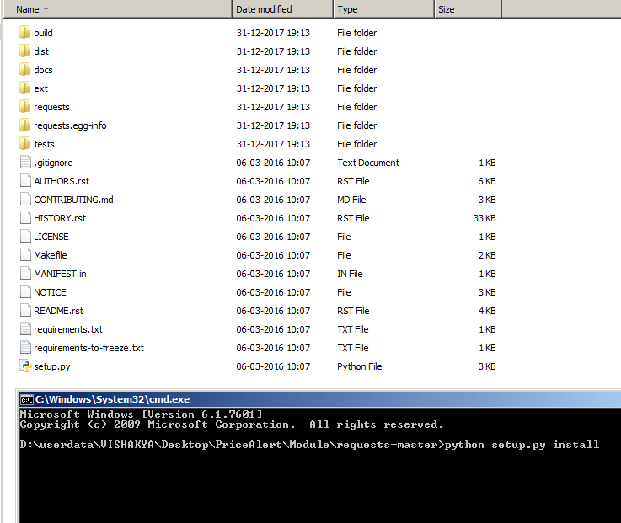

**Note:**

*All the required packages are available in Module directory. but I would recommend to download them from official site. We should not trust anybody when it comes to security. In case, if you don’t find the packages, you can trust me :)*

# EXECUTION STEPS

*There are multiple ways to run* ***PriceAlert.py*** *script. you can choose anyone but I would recommend 3rd option which is more user friendly.*

1. Open ***PriceAlert.py*** script with python shell ***(IDLE)*** and press ***f5*** button to run the script.
2. Go to unzipped ***PriceAlert-master*** directory.

* *Open command prompt. (click in address bar, type* ***cmd*** *and press enter)*
* *Run below command in* ***cmd.***

***Python PriceAlert.py***

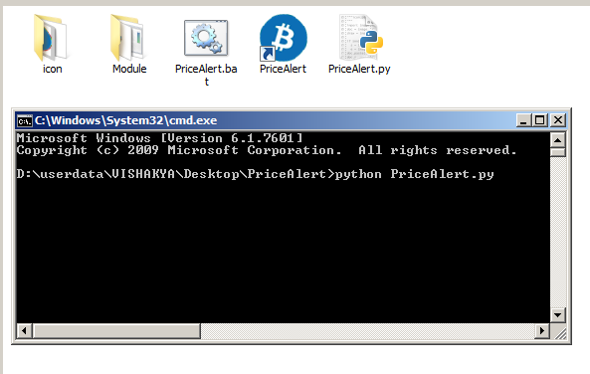

1. Open ***PriceAlert*** shortcut with notepad, edit the ***PriceAlert.py*** script path and save it.

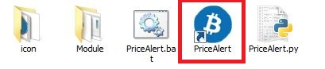

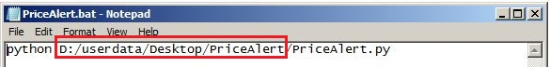

*Now you can run this script by just clicking on* ***PriceAlert*** *shortcut. Minimize the command prompt and continue with your work, you will start getting the price alert notification :)*

If you want this command prompt to be auto minimized and set icon for command prompt,

* *Right click on* ***PriceAlert*** *shortcut.*
* *Select* ***Properties.***
* *Give* ***PriceAlert.bat*** *file path in* ***Target*** *field.*
* *Give* ***PriceAlert*** *directory path in* ***Start in*** *field.*
* *Select* ***minimized*** *from dropdown menu next to* ***Run*** *field.*
* *Click on* ***Change Icon*** *tab, browse the* ***bitcoin.ico*** *file available in* ***icon*** *directory of shared* ***PriceAlert*** *package and click* ***OK****.*
* *Click* ***Apply*** *&* ***OK****.*

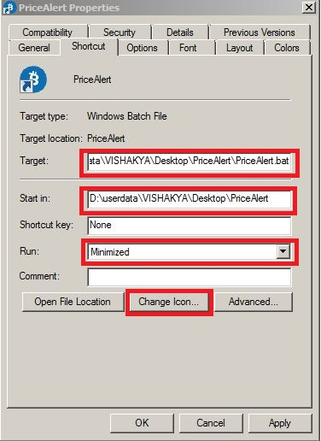

**Note**:

* *You can copy this shortcut to the desktop for more convenience.*
* *In this script, I used* ***WindowsToolTip*** *for notification so you can play with* ***WindowsToolTip*** *setting for better appearance of the Notification****.***
* *In the next section, we will see how to change* ***WindowsToolTip*** *& other settings for better appearance of the Notification. That is optional and it’s up to you whether you want to change or not.*
* *By default, Notification will appear after every 10-15 mins, you can change this time in the script.*
* *Open* ***PriceAlert.py*** *script with notepad or python shell (IDLE)*
* *Go to 3rd last line of the script.*
* *Change the time interval (in seconds) as per your need.*

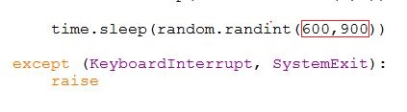

# NOTIFICATION APPEARANCE SETTING (OPTIONAL)

*Below steps are optional and its completely up to you whether you want to proceed or not.*

1. Change ***Taskbar location on screen*** to ***top***.

* *Right click on* ***Taskbar****.*
* *Select* ***properties****.*
* *Select* ***Taskbar location on screen*** *to* ***top*** *from dropdown menu.*
* *Click* ***Apply*** *&* ***OK*** *button.*

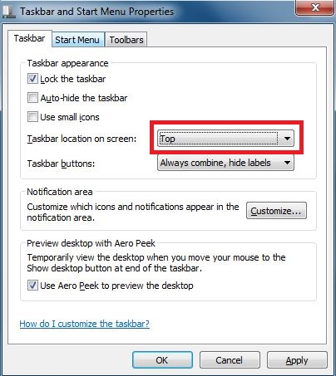

1. Change ***WindowsToolTip*** setting.

* *Right click on* ***Desktop****.*
* *Select* ***Personalize.***
* *Click on* ***Windows Classic.***

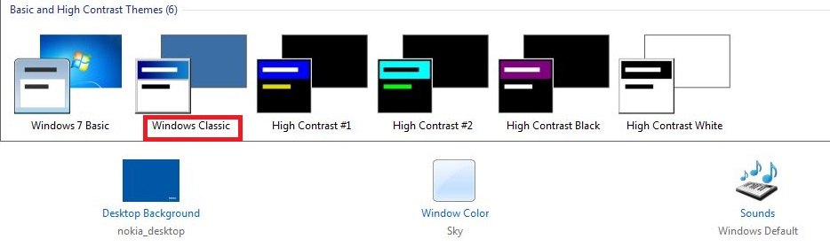

* *Click on* ***Window Color****.*

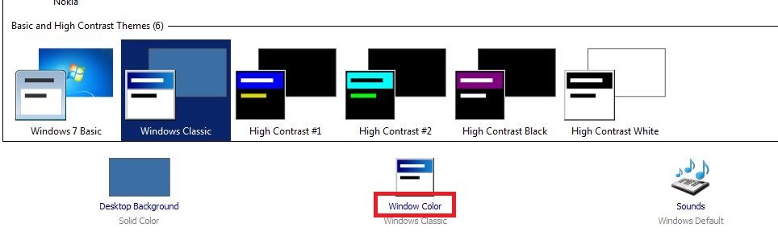

* *Select* ***ToolTip*** *from* ***dropdown*** *menu, select* ***Font/Size/Color*** *of your choice and click on* ***Apply*** *&* ***OK*** *button.*

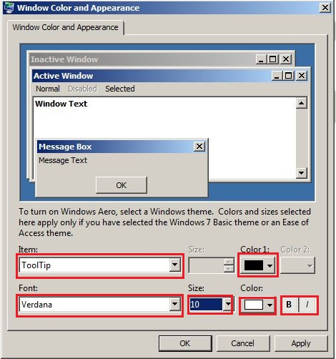

**Note**:

* *After changing above mentioned settings, you might feel bit uncomfortable while using your system but with time, you will get used to it.*

***Someone has rightly said that good things come with a price :)***

* *If you have any suggestion or query, please feel free to reach me.*

***Email ID:*** *vikasshakya00@gmail.com*